Linear Regression Model
- Linear Regression:
Linear regression is a statistical and machine learning method used to model the straight-line relationship between an input variable and an output variable.
- Independent Variable (X): The input factor or predictor used to make a forecast.
- Dependent Variable (Y): The target outcome you want to predict.
- Best-Fit Line: A straight line that passes through maximum data points that minimize the distance between the actual data and the predicted line.
The model uses a simple mathematical formula:
y = mx + c
Here,
- x is the input
- y is the output
- m is the steepness of line(slope)
- c is y-intercept (value of x at y=0)
- About Data:
This is a simple dataset to start with. It contains only the height (inches) and weights (pounds) of 25,000 different humans of 18 years of age. This dataset can be used to build a model that can predict the heights or weights of a human.

Acknowledgement
Link: http://socr.ucla.edu/docs/resources/SOCR_Data/SOCR_Data_Dinov_020108_HeightsWeights.html
Scraped the aforementioned HTML page using a Regex Parser. (BeautifulSoup - Python)

Inspiration
Build a predictive model for determining height or weight of a person. Implement a regression model that will be used for predicting height or weight.
  - Source
Link: kaggle data set

- Basic EDA:
  - Shape of DataSet:
This Data have 3 columns and 25000 rows.
  - Column names & data types:
Column names | Datatypes
Index | int64
Height(Inches) | float64
Weight(Pounds) | float64

  - Droping columns:
Index already exsist in pandas data frame so ‘index’ column from this data set have been droped.
  - Changing column names:
Column names for this data set have been change to easier notations. Following are new column names:
Old column names | New column names
Height(Inches) | height_inch
Weight(Pounds) | weight_lb
  - Data Overview:
Following table shows data description in one view:
 | height_inch | weight_lb
count | 25000 | 25000
mean | 67.993114 | 127.07942
std | 1.901679 | 11.660898
min | 60.27836 | 78.01476
25% | 66.704397 | 119.30868
50% | 67.9957 | 127.15775
75% | 69.272958 | 134.89285
max | 75.1528 | 170.924
  - Missing Values:
This data have NO missing values
  - Duplicate Values:
This data have NO duplicate values

- Splitting data
Data has been split into 70% for training set and 30 % to test data.
- Model Fitness:
  - Score:
 | Score
Training data | 0.25241033931863766
Testing data | 0.2537860641652152

Fitness score for training and testing data is same up to 2 decimal points that shows that model is extremely fit.
  - Graph:
The following scatter plot shows the relationship between height and weight in the training dataset. The blue points represent the actual height and weight values of 500 individuals, while the red line represents the weights predicted by the linear regression model. The upward slope of the red line indicates a positive relationship between height and weight, meaning that as height increases, the predicted weight generally increases. However, the blue points are spread around the regression line, showing that height alone cannot perfectly predict weight and that other factors may also influence a person's weight.

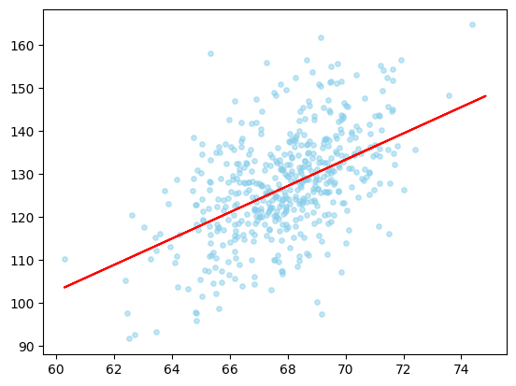

- Key Findings:
- A simple linear regression model built to predict weight from height using a dataset of 25,000 records of 18-year-olds.
- NO missing values were found.
- NO duplicates were found.
- The model achieved an R² score of ~0.25 on both training and test data.
- NO overfitting.
- The scatter plot with the fitted regression line confirmed a positive correlation.
- Test predictions on new height values produced reasonable weight estimates within the training data's range.
- height is a useful but insufficient single predictor of weight
- incorporating additional features (e.g., age, gender, body frame) via multiple linear regression could significantly improve predictive accuracy in future work.
- Appendix:
Notebook link:

Libraries used:
- Numpy
- Pandas
- Matplotlib
- Seaborn
- sklearn

- Author:

- Muhammed Sudais Amin
- [Sudais-apk]: Git hub Link
- [Muhammad Sudais Amin]: Muhammad Sudais Amin | LinkedIn

